|  |
| --- |
| SYI Games |
| 3D Action Game |
|  |
| Version #0.2.2  All work Copyright © 2015 by SYI Games.  All rights reserved. |
| **[Sangbeom Yi; 300857600]** |
|  |

**Logo.png**

|  |
| --- |
| October 5, 2015 |

**Table of Contents**

[Your Table of Contents should go here. Make sure that your document’s sections are hyperlinked to their corresponding pages.]

**# GitHub (it’s more newest than eCentennial Dropbox)**https://github.com/SeanSBYi/COMP305-Final-3DGame/

**Version History**

--------------------------------------------------------------------------------

All Source code has each version History

|  |
| --- |
|  |
| C:\Users\SB.Y\AppData\Local\Microsoft\Windows\INetCache\Content.Word\Cap 2015-11-20 09-43-43-290.png |

--------------------------------------------------------------------------------

Version 0.1.0  
Create default Camera, Player, Light

Version 0.1.1  
 Create Terrain

Version 0.1.2  
Create Enemy, Animation and AI

Version 0.1.3  
Player Animation, Player attack to Enemy, Enemy attack to Player

Version 0.1.6  
Game Flow (Title->Game->Game Over)

Version 0.1.7   
Add attack Effect

Version 0.1.9  
Stage 1 Basic Stage

Version 0.2.0  
New Scene (Town)

Version 0.2.1  
Add UI (Player Score, Player HP)

Version 0.2.2  
Drop Item

-----------------------------------------------------------------------------------------

1. **Game Overview**

*Kill the Enemy. Player has to get the high score!*

1. **Game Play Mechanics**

*Hit and Kill the enemy.*

1. **Camera**

*3D 3rd Person Action Game*

1. **Controls**

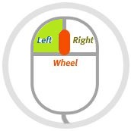

* *Left Mouse : Moving, Attack the Enemy*
* *Left Mouse Click+Move : Moving Camera View*

1. **Menu and Screen Descriptions**

[UI]  
If timer is 0, game over.

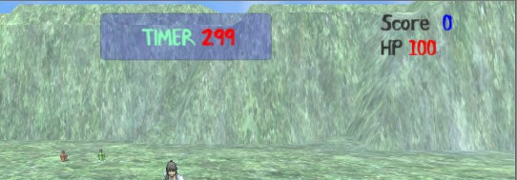

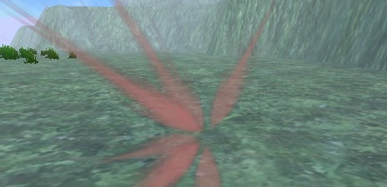

*[Hit Effect (When Enemy hits)]*

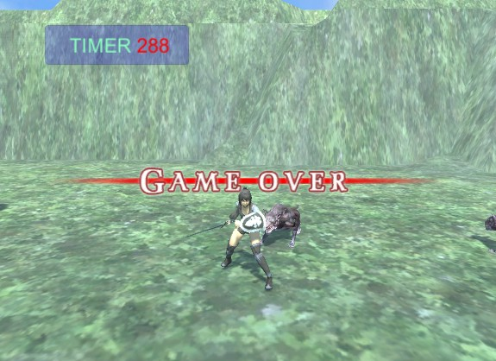

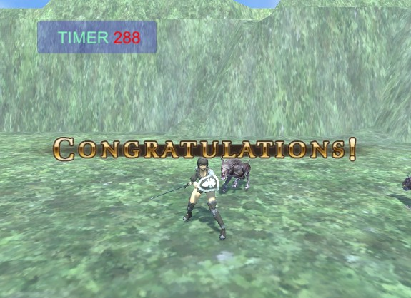

*[Game Over, Clear]*

1. **Game Progression, Levels**

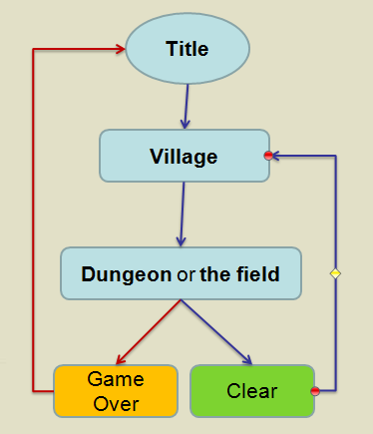

**[Stage 1: Forest]**

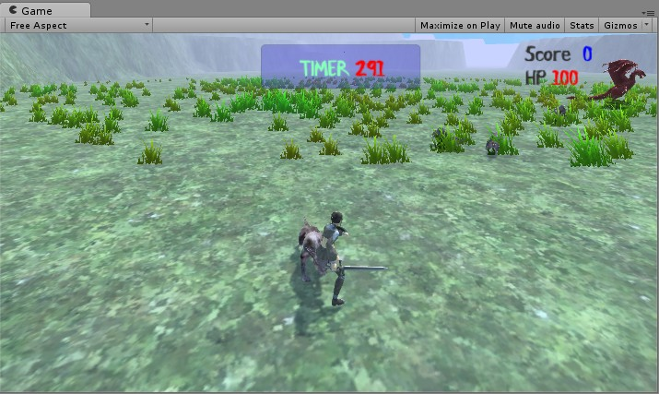

**[Stage 2: Desert]**

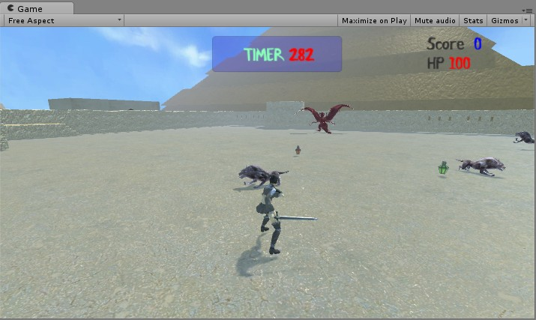

**[Stage 3: Snow]**

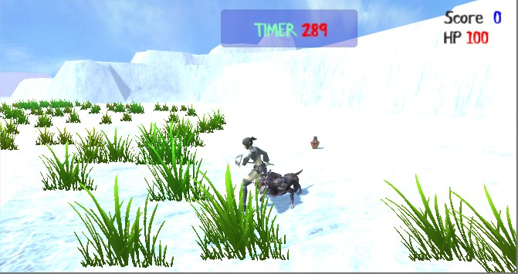

1. **Enemies, Non-player Characters**

*All enemies follow the player and hit the player.*

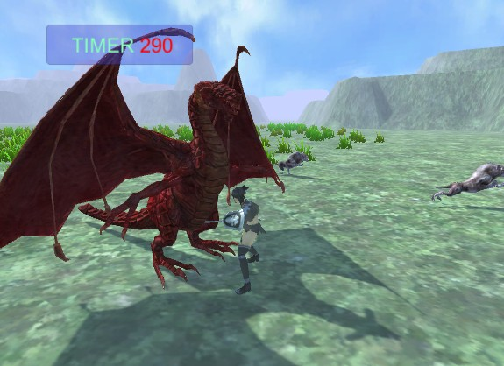

*[Boss Enemy]*

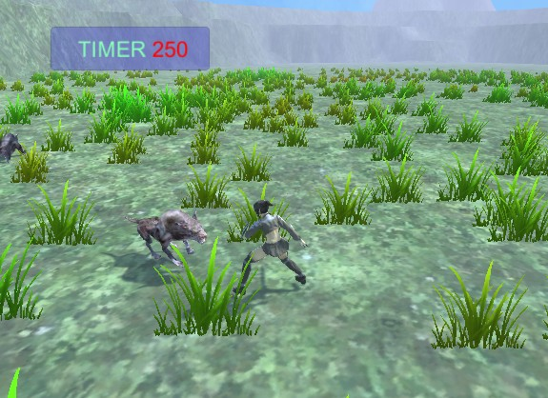

*[Normal Enemy]*

1. **Sounds**

BGM: Stage Sound  
Effect: Player Enemy Attack, Pick up Item…

#Open Source :  
http://www.econovation.co.kr/ecnvb/%EA%B0%9C%EB%B0%9C%EC%9E%90-%EC%A7%80%EC%9B%90/%EC%98%A4%ED%94%88%EC%86%8C%EC%8A%A4/

1. **Items**
2. *Attack Up!*
3. *HP Recover*
4. *Shield (not yet)*
5. *Double Score (not yet)*
6. **Scoring**

*Enemy : 10 point*

1. **Future Features**

*Various Player’s Weapon*

*Various Type of Enemy*

*New Design and Animation*

*Various Items*

*New Stage  
 Other Field*

*Make a Village  
 NPC*

***Support Game Controller***